Software
Design Model
for the
Gin Rummy Simulation System

Submitted by

<Michael Jenzen, Jacob Sarvis
Andrea Kosta, Jon Calhoun>

COP 4331

Spring 2009
Table of Contents

1.0 Introduction 1
1.1 Document Purpose 1
1.2 Document Scope 1
1.3 Definitions, Acronyms, and Abbreviations 1
1.4 References 1
1.5 Document Overview 1
2.0 Overview and Summary of the Simulation System 2
2.1 Project Motivation and Business Analysis 2
2.2 The Virtual World Model 2
2.3 Assumptions and Dependencies 2
3.0 External Interface Specifications 3
3.1 Input File Specifications 3
3.2 Output File Specifications 3
3.3 Interactive User Interface Specification 3
4.0 Internal Software Specification 4
4.1 Architectural Overview 4
4.2 Package Specifications 4
4.3 Class Specifications (SimModels only) 4
5.0 Implementation Summary 5

List of Figures

List of Tables

1.0 Introduction

1.1 Document Purpose

This document was prepared for our client NAME, the casino owner. It proposes the development of a simulation system for modeling the game of Gin Rummy at a casino table by detailing the external interface, internal architecture, and implementation of the simulation. While this document also describes many of the rules of Gin Rummy, this document should not be consulted as an official rulebook.

1.2 Document Scope

This document describes the design specifications for the simulation of the card game of Gin Rummy from the perspective of the developer. The software product to be produced shall be named Gin Rummy Sim and will monitor player data throughout the execution of the game, collecting necessary information to determine the most profitable playing strategy.

This product will be utilized by the casino chain owner to determine which playing strategy his Gin Rummy dealers need to use. By using this product, the owner will save himself the time and money that it would otherwise determine the more profitable strategy.

1.3 Definitions, Acronyms, and Abbreviations

Big Gin - prior to knocking, if all 11 cards in a player's hand form a legal gin, the player can retain the extra card as part of their hand, and is awarded an extra 6 points per the "Big Gin" bonus.

Deadwood - a player's "deadwood" cards are those not in any meld

Deadwood Count - the sum of the point values of the deadwood cards

Deck - a standard 52-card pack of playing cards

Game Bonus - once a player has acquired 100 points (or some other agreed upon number) the match is over, and that player receives a Game Bonus of 100 points.

Gin Bonus - after going Gin, a player receives a bonus of 25 points plus the entire count of deadwood in their opponent's hand. There is no chance to lay off when a player goes Gin.

Knock Points - after a player knocks, and the lay offs are made, the knocking player receives a score equal to the difference between the two hands. For example, if a player knocks with 8, and the defender has 10 deadwood points in his or her hand after laying off, the knocking player receives 2 points for the hand.

Line Bonus - (also known as a box bonus) is added at the end of the match. For every hand a player won during the match, 25 points is added to their score.

Meld - a set of matching cards, typically three or more, that earn a player points and/or allow him to deplete his hand.

Shutout Bonus - if a match is completed with the winner having won every hand, the points for each hand are doubled before adding the Line Bonus.

UnderCut - (sometimes called underknocking) occurs when the defending player has a deadwood count lower than or equal to that of the knocking player (this can occur either naturally or by laying off after a knock). In this case, the defender scores an undercut bonus of 25 points plus the difference between the two hands. (In some rule sets, the bonus is only 10 or 20 points, or is not awarded in case of a tie.)

1.4 References
Wikipedia’s article on Gin Rummy
Title: Gin Rummy, Report Num: N/A, Date: 5/22/2008, Publishing Org: Wikipedia, Source: http://en.wikipedia.org/wiki/Gin_rummy

Dr. David Workman’s guidance document on Software Design Specification
Title: Software Design Specification, Report Num: N/A, Date: Fall 2008, Source: http://www.cs.ucf.edu/~workman/cop4331/

1.5 Document Overview
This subsection should
a) Describe how the rest of the document is organized.
b) Summarize the content of each major section.

2.0 Overview and Summary of the Simulation System

2.1 Project Motivation and Objectives

Our client owns a chain of casinos in the Las Vegas strip. Over the last few months, he has been receiving complaints as to the lack of variety in the cards section of his casinos. Currently, the casinos only have poker and blackjack tables. The owner has decided another card game must be added to his repertoire to keep customers interested. After sleuthing around in competitor’s casinos, he has discovered that almost every casino has tables allocated to Gin Rummy in addition to poker and blackjack. In order to keep up business, Gin Rummy is going to be added to the casino’s card floor. After a bit of research the owner has discovered that there are two main play styles attributed to Gin Rummy, a beginner strategy and an advanced strategy.

The main objective of the beginner strategy is to reduce deadwood count and knock as quickly as possible. The beginning player accomplishes this by three main rules. First, the player tries to make as many sets and runs as possible by melding cards. Second, the player discards the highest un-melded card. Third the beginning player knocks as soon as possible.

The advanced strategy involves more complexity and takes into account more than just short term strategies. The first rule observed by an advanced player is that middle cards are more valuable than high or low cards. This is because they can be used in more runs that any other cards. The second rule is to weigh the possibilities of the opponent undercutting. The chances of this increase towards the end of the deck and the decision to knock should be weighted against the probability to get Gin on the next turn. The third rule uses knock value to determine when to knock. If a player has a high knock value, the player should knock quickly and not give the opponent a chance to get a lower knock value than him. Alternately, if a low knock value is achieved, the player can afford to wait to knock and go for gin as it is unlikely that the opponent can beat him. A Fourth rule is to hold onto high cards at the beginning of the game. This is beneficial because your opponent may try and get rid of all high cards at the beginning of the game, allowing easy runs or sets.
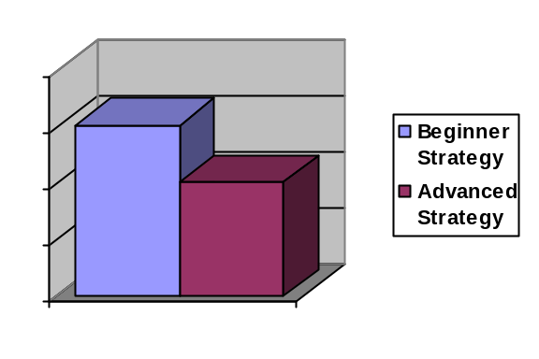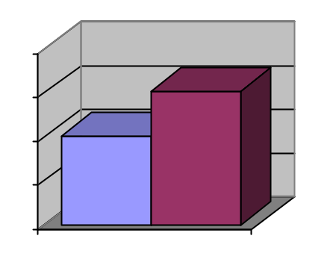

In Order to maximize profit, the owner has contracted a third party to figure out which strategy is more profitable. Using live tables to figure out which strategy is more profitable may take months. It could also end up costing the casino money at the tables with inferior strategies, as the casino dealer is an actual player in the game and is expected to play using the appropriate strategy to win money for the casino. With the results of this simulation available in minutes, the casino is free to plan on adding Gin Rummy to the card floor by the next fiscal year.

The Virtual World Model

Figure “X” illustrates a model of the virtual world encompassed by the Gin Rummy Simulator. A typical game scenario begins when the players’ hands and the initial discard pile card are dealt. The numbered boxes on the diagram indicate the relative sequence in which actions and events occur.

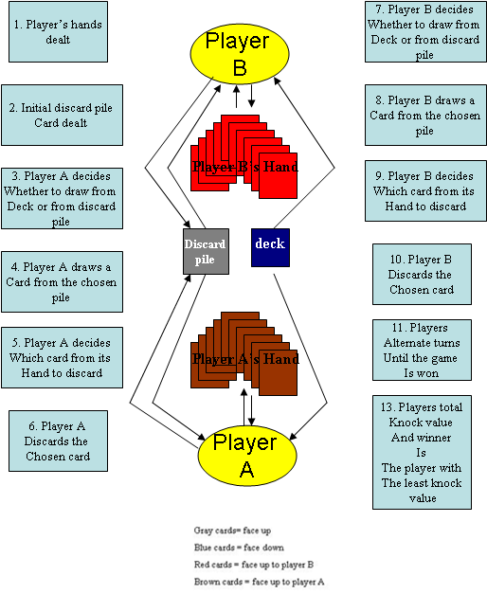
Figure “X”: Virtual Model of Gin Rummy Simulation

The simulator shall provide realistic parameters for the rate at which the cards are initially dealt, the rate at which player decisions are made, and the amount of time a turn should take. The amount of time a game should take will depend on the length of time an average turn takes and the number of turns. The simulation shall end when a player has knocked and the winner has been determined.

Simulation output (elaborated in more detail in Section 3.2) shall include the total time of the scenario measured starting when the cards are dealt, until the game ends and the winner is determined by totaling knock count. The output shall also include the average time spent per turn and the number of turns in the game. The output shall include the knock value of both players and the winner of the game. The time fidelity (length of a clock tick in simulation time) shall be no longer than 1 second of real time.

2.3 Assumptions and Dependencies

This subsection shall include all dependencies on and assumptions relating to third-party products, subcontractors, governmental laws and regulations, or finally on emerging industry standards should be discussed in this section. This section is important to help identify sources of project risk.

3.0 External Interface Specifications

3.1 Input (File) Specifications

The Gin Rummy simulation shall be initialized with an input file that contains key information necessary for game play. Specifically, the input file will contain the all of the following data:

First, program control and statistical constants are provided:

- the amount of seconds that occur per simulation clock tick
- the number of rounds to be simulated before outputting statistical data and terminating the simulation

Then the player’s amount of delay time for decisions and actions taking place throughout the game is provided, such as:

- the amount of time that is necessary to initially sort the cards that have been dealt to their hand, so the player can be mentally organized and make wise game decisions during the game
- the amount of time that it takes a player to draw a card
- the amount of time that it takes a player to discard a card
- the amount of time necessary for a player to make a decision regarding which card to pick up
- the amount of time necessary for a player to make a decision regarding which card to discard

The input file then specifies the strategy that the player will be using, which will be either ‘Beginner’ or ‘Advanced’. Additional numeric constants that are used by the strategy’s algorithm are then provided.

In addition to the specific delay times for game actions and decisions and strategy choices provided for the player, the dealer will be given the following delay times:

- the amount of time that is necessary to shuffle cards
- the amount of time that is necessary to deal those cards
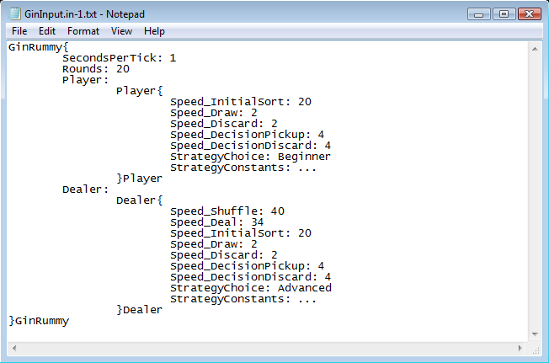

3.2 Output (File) Specifications
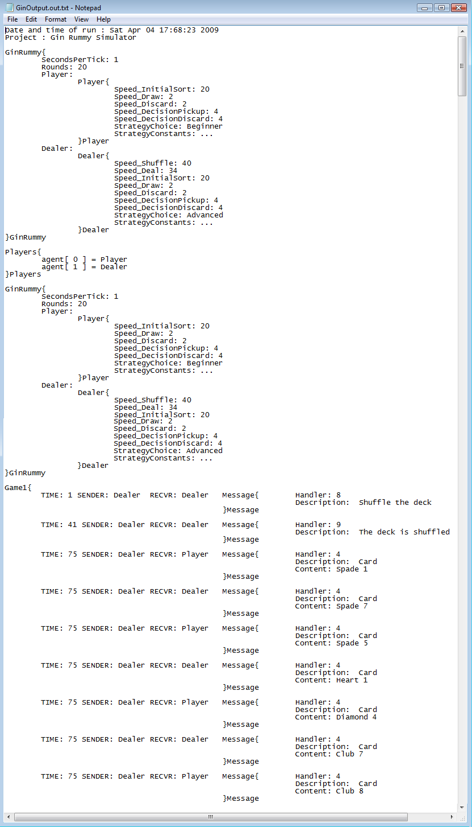

This subsection shall include a detailed description of all non-interactive output data sinks. A complete set of example output data records, files, streams, etc., should be provided to illustrate the specifications given in this subsection. These can be provided as appendices with appropriate descriptive references given in this subsection. (E.g. Output File Specification)
- Event Log
- Post Simulation Report

3.3 Interactive User Interface Specification

The Gin Rummy Simulator interacts with the Simulation Analyst via a simple command-line interface. Figure X illustrates the Gin Rummy Sim display screen when prompting the user for the name of the input file (Specify Input use case). Figure Y shows the dialog where Gin Rummy Sim prompts for the name of the simulation log. Figure Z shows the final screen after the simulation has completed successfully.

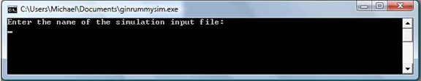
Figure X: Specify Input User Screen.

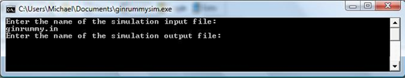
Figure Y: Specify Output User Screen.

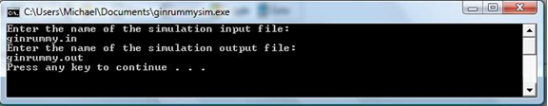
Figure Z: Final Gin Rummy Simulator Screen – Successful Completion.

4.0 Internal Software Specification
This subsection shall include a specification of the software architecture and design of the subject system. This serves as a blue print for implementation.

4.1 Architectural Overview
This subsection describes the high-level software architecture of the system including both its static view and its dynamic view.
- Static Models
  - Package Organization and Relationships
  - System Class Diagram (Layers: Control classes, Active or Agent subclasses, Message subclasses, and Passive classes)
- Dynamic Models
  - System Activity Diagram showing process flow
  - Agent Communication or Interaction Diagrams showing message types sent from each Agent subclass to another – describe purpose and content of each message.
  - System Sequence Diagrams (see class notes)

4.2 Package Specifications
The simulation consists of three major packages. Only one of these need be modified to enhance or alter the simulation in any way. This section describes the purpose each package incorporated in the simulation and gives an overall view of which classes are utilized. Figure 4.2-1 introduces an overall view of each package and the classes contained within each package. Key relations among the classes are also illustrated in figure 4.2-1.

Package IOMgmt.
This package primarily provides classes to control file streams, as well as error classes to be utilized by any class that will access a file stream. The primary classes are InMgr and OutMgr which are used to control file input streams and file output streams respectively. Both of these classes use the IOError class to generate and throw exceptions that occur during stream operations, such as append(). TokenError on the other hand is a class provided for any application that incorporates the InMgr class. TokenError is used to generate and throw exceptions caused while parsing data from the input stream, such as an invalid instance of a class, and is used by all classes of SimModels that include Extract() and Get() functions.

Package SimMgmt.
The SimMgmt package contains the classes that do not need redefined for any simulation, but instead are built upon by classes inside of SimModels.

Included in the SimMgmt package is the Agent class. Agent is an abstract class that any active object in the simulation must extend, and therefore redefine certain methods contained in Agent. This is illustrated in figure 4.2-1 by the Player class in SimModels.

SimMgmt also includes theEventMgr, an instance of the EventMgr class that is used to manage events throughout the simulation. This includes providing a method for adding and removing events from the queue (PostEvent() and getNextEvent()) as well as the MoreEvents() method, one that determines if the event queue is empty. EventMgr also provides methods for determining the sender of a message (GetSendr()), determining the receiver of a message (GetRecvr()), and methods to provide the message being sent and the clock time (GetMsg() and Clock()).

SimMgmt also provides access to predefined input and output file streams (simInMgr and simOutMgr) that utilizing the InMgr and OutMgr classes of the IOMgmt package.
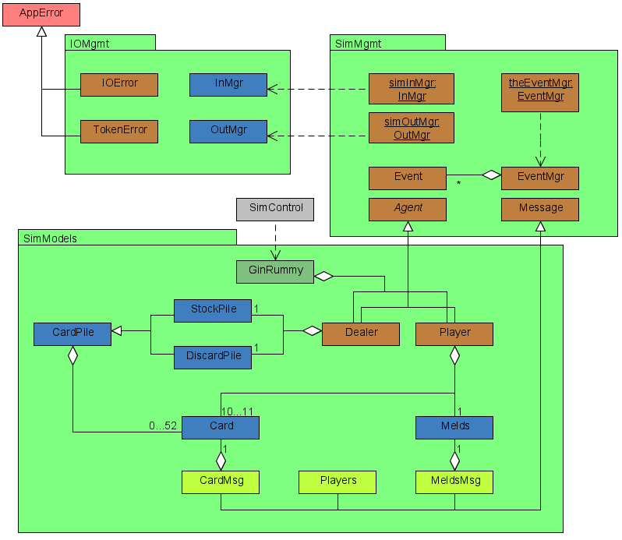
Figure 4.2-1. GinRummy Package Contents and Relationships

Package SimModels.

4.3 Class Specifications (SimModels only)
Begin with a section presenting a “roadmap” of how classes are organized.
(4.3.1 Agent subclasses)(4.3.2 Message Classes)(4.3.3 Passive classes)
End this opening section with a TOC listing: Class, Package, page #, alphabetically by class.

Each class description should provide the following information:
- Class Name
- Containing package
- Type of class (boundary, control, entity, exception)
- Purpose of class and its functional capabilities and behavior. List the use cases that call methods of this class.
- List of data members (Attribute Table) and their specification (purpose and type). Include as a minimum the data members that directly represent problem data identified in use case specification.
- Give the specification of all methods (Method Table) (public, protected, private) and give their visibility.(Method Table) This information must include: name, parameter profile, result profile for functions, purpose of the method (if not obvious from its name), the methods called in other classes and packages (required services), and any exceptions it raises.
- Class protocols and exception conditions. This protocol should describe constraints on use of the class, such as its internal states and the methods that may be called in each state (e.g. give a state diagram of the class behavior). Discuss exceptions that are raised and the circumstances that trigger them.
- For Agent subclasses only, include a State Diagram showing its simulation states and transitions (events or messages). Summarize what agents receive messages from this class and what agents this class receives messages from. Fill in the Interaction Tables below for classes of all kinds (not just for Agents).

Client Table
Class::Client Method | Methods Called in This Class

Server Table
Method of This Class | Class::Method(s) called from This Method  (exclude library methods)

5.0 Implementation Summary
- Summarize progress (what was implemented and tested, what was not).
- Lessons Learned on this Project.
- Development platform, environment and restrictions for compilation/execution.
- Installation and demonstration requirements.
- Sample input and output (Appendices).

